Briefing Notes: Mental Health Priorities
Housing
Why Are Housing Programs Important for People with Mental Illness?
Severe mental illness has a wide-ranging impact on people’s lives, affecting employment, education, and income, which in turn affects housing. Without a stable living situation that includes supportive and preventive services, many people cycle among hospitals, treatment facilities, jails, homeless shelters, and the street. s
- Approximately 20% of adults in homeless shelters live with severe mental illness (SMI), and 46% live with SMI and/or a substance use disorder.¹
- 11.5% of adults in a large public mental health system were incarcerated during a 2005-06 study.²
For adults living with mental illness, the continuum of housing options in the community breaks the cycle by offering stable housing along with the necessary support services.
- The continuum includes Supportive Housing, Supported Apartments, Supervised Apartments, and Group Homes. Each level of care increases in terms of the intensity of services and supervision provided.
- The goal is to help residents live an independent life and contribute to the community.
- Support services can include case management, medication management, crisis planning and intervention, and help with independent living skills such as budgeting and travel. Transportation is also a challenge for many.
For children and teens with severe behavioral health problems who are not successful in their own homes or in foster care, the state supports and monitors Residential Treatment Centers and Therapeutic Group Homes. These are congregate-care facilities where young people receive therapy and support aimed at reintegration into the community.
Stable Living Situation + Support Services = Proven Success
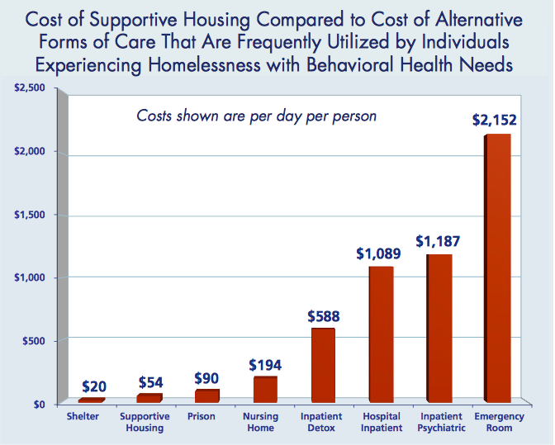
Supportive housing is effective because people are in a safe and stable community environment, connected with needed services. An evaluation of supportive housing in Connecticut conducted by Arthur Anderson, LLP showed a 71% reduction in use of inpatient care, an increase in tenant participation in education and employment, and an increase in neighborhood property values.
Supportive housing costs much less than other forms of care and housing frequently used by people with mental illness. Compared with the substantial daily cost of the emergency room ($2152), inpatient psychiatric care ($1187), inpatient detox ($588), or even incarceration ($90), supportive housing is extremely cost-effective, at an estimated $54/day. (See chart.)³
¹National Alliance on Mental Illness, 2013.
²Hawthorne, William B., David P. Folsom, David H. Sommerfeld, Nicole M. Lanouette, Marshall Lewis, Gregory A. Aarons, Richard M. Conklin, Ellen Solorzano, Laurie A. Lindamer, and Dilip V. Jeste. "Incarceration Among Adults Who Are in the Public Mental Health System: Rates, Risk Factors, and Short-Term Outcomes." Psychiatric Services 63.01 (2012): 26-32.
³Partnership for Strong Communities, 2013.
Housing Challenges in Connecticut
Housing is a challenge throughout the state and continues to be the #1 priority in the southwest region.
- There is a shortage of all types of housing: affordable and subsidized housing, supportive housing, and emergency shelter beds. The shortages affect the ability of individuals to step down from one level of care to the next, even when they are ready, creating bottlenecks from the inpatient level on down.
- Medicaid reimbursements for therapeutic group homes are a challenge. As a result, one group home in the SW region closed its doors and no other provider was willing to open another such facility. The result was a loss of 8 beds for those with the most intensive needs.
- There is a missing level of care for people with severe mental illness who require multi-year treatment in a congregate setting. The existing group homes are intended to be transitional, yet there are those who may require a permanent level of care. The “Permanent Supportive Housing” that exists for people who have experienced chronic homelessness may and/or who have complex health conditions does not meet the therapeutic needs of some people in this demographic group.
State and Regional Housing Costs
- Connecticut has the 6th highest rental costs in the nation.
- Fairfield County has by far the highest cost of living in the state.
- Stamford-Norwalk is now the 9th most expensive rental market in the nation. The fair market rent for a 2-bedroom apartment is $1551/month, requiring a “housing wage” of $29.83/hour—more than 3 times the minimum wage.
- Individuals who are ready to live independently face a lack of affordable housing. Fairfield County has the highest cost of living in the state and is one of the most expensive rental markets in the country.
Historically, people with severe mental illness were housed in psychiatric institutions, often for decades. During the deinstitutionalization of the civil rights era, Connecticut and other states began closing their psychiatric hospitals. The hospital funding was intended to follow those who were discharged, providing for intensive services in the community. That promise was not kept, and community services for mental illness have been overburdened and underfunded. Many individuals have ended up homeless or imprisoned for lack of appropriate treatment. Currently, the Department of Children and Families is working to close some of its congregate care facilities with the same goal of treating clients in the community. It will be critical to avoid the same mistake and to ensure that the funding follows the clients.
Legislative Action in 2014
- Supportive Housing was expanded to include an additional 110 units of scattered site supportive housing and $1.1 million for supportive services through the Governor’s Mental Health Initiatives.
- The Housing Assistance Fund (HAF) received $1 million to address the rental assistance needs for individuals in the DMHAS system waiting for other housing programs.
What Can Legislators Do?
- Support legislation to increase the number of units of supportive housing available to people with mental illness.
- Support legislation that increases reimbursement rates to permanent supportive housing providers.
- Insure that when/if institutions or providers close, funding remains dedicated to the behavioral health system.

